Batch: D2 Roll No.: 25

Experiment / assignment / tutorial No. 4

Grade: AA / AB / BB / BC / CC / CD /DD

Signature of the Staff In-charge with date

TITLE: Program to print patterns

Expected OUTCOME of Experiment:
AIM: Program to print patterns for ‘n’ rows using nested loop ______________________________________________________________________

_____________________________________________________________________
Books/ Journals/ Websites referred:

- Programming in C, second edition, Pradeep Dey and Manas Ghosh, Oxford University Press.
- Programming in ANSI C, fifth edition, E Balagurusamy, Tata McGraw Hill.
- Introduction to programming and problem solving , G. Michael Schneider ,Wiley India edition.
- http://cse.iitkgp.ac.in/~rkumar/pds-vlab/

_____________________________________________________________________

Problem Definition:

The program is to print a pattern as given by the user. The program makes use of a nested loop to print a pattern of characters, numbers or alphabets.

Example:
Input: number of rows = 4, number of columns = 4

Output:
5
4 5
3 4 5
2 3 4 5
1 2 3 4 5

Algorithm:
STEP 1: START
STEP 2: Input number of lines to be printed from the user.
STEP 3: Initiate a for loop to iterate from 1 to number entered by user.
STEP 4: Initiate a nested for loop to print spaces.
STEP 5: Initiate a for loop to print the required series.
STEP 6: END

Output(s):

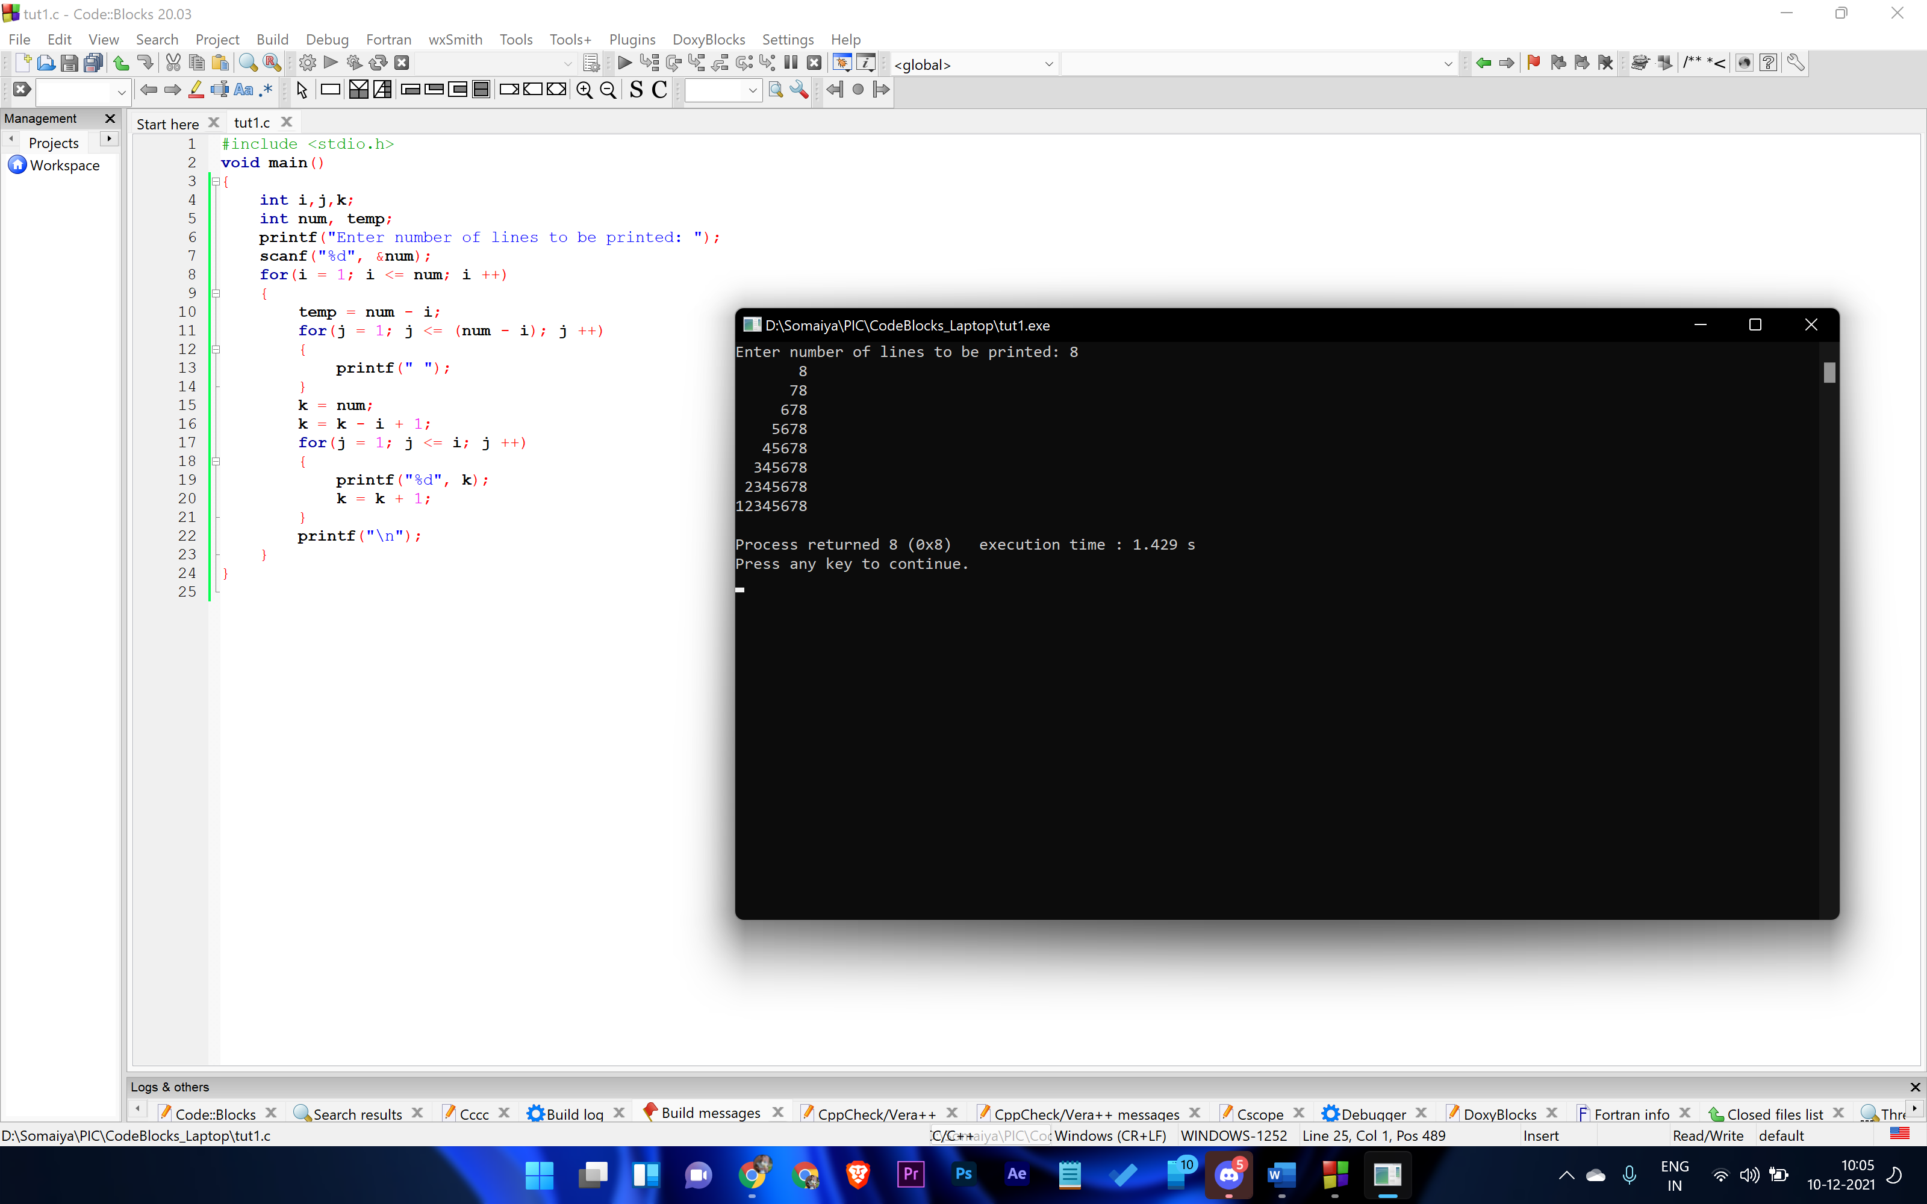

Conclusion: Using nested for loop we can print any sort of triangular series.

Post Lab Descriptive Questions

Write a program to print the following:
1
2 4
3 6 9
4 8 12 16
5 10 15 20 25
6 12 18 24 30 36
7 14 21 28 35 42 49
8 16 24 32 40 48 56 64
9 18 27 36 45 54 63 72 81
10 20 30 40 50 60 70 80 90 100

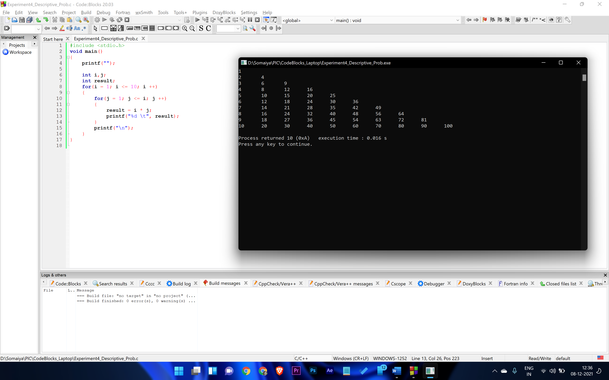

Code:
#include <stdio.h>
void main()
{
int i,j;
int result;
for(i = 1; i <= 10; i ++)
{
for(j = 1; j <= i; j ++)
{
result = i * j;
printf("%d \t", result);
}
printf("\n");
}
}

Date: _____________ Signature of faculty in-charge

